Scrum Summary

for
CitiSense: A Smart Web App for Automated Bilingual Feedback Processing and Data Visualization

Prepared by
Group Name: QuadThink
Lorenzo Emil S. Bernal | 2023-140197 | lsbernal@student.apc.edu.ph
Gabrielle J. Cabangcala | 2023-140039 | gjcabangcala@student.apc.edu.ph
Luis Lorenzo Lazaro | 2023-140004 | ldlazaro2@student.apc.edu.ph
Mark Lyster C. Marabi | 2023-140272 | mcmarabi@student.apc.edu.ph

01/05/26

Sprint Planning – 12/4/25 & 12/9/25
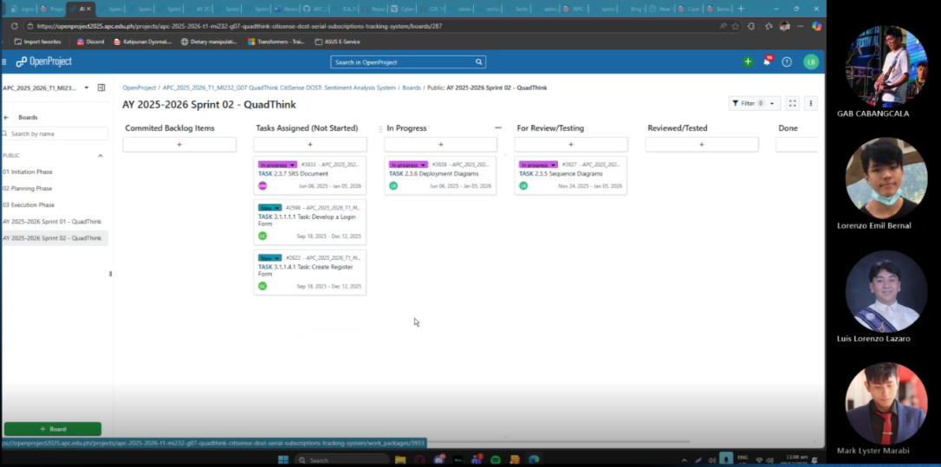

Recording – 1st part: Meeting in QUADTHINK-20251204_204433-Meeting Recording.mp4

Recording – 2nd part: Meeting in QUADTHINK-20251209_110553-Meeting Recording.mp4

Note: We had to do two sessions of sprint planning because we forgot to add the development of the login and register forms in the 1st sprint planning session.

Sprint Review with Sr. Manuel Calimlim – 12/17/25
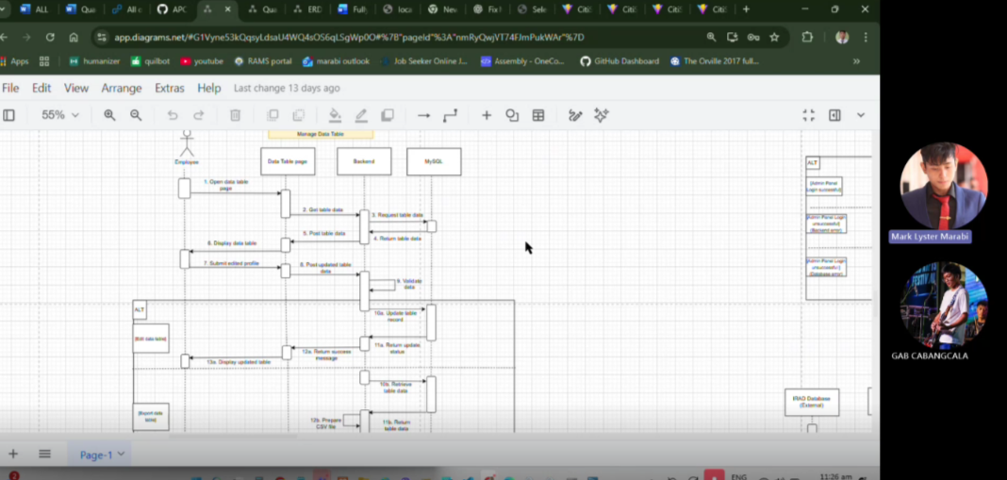

Recording with Sr Manuel Calimlim: Recap: QUADTHINK weekly meeting with Adviser Wednesday, 17 December | Meeting | Microsoft Teams

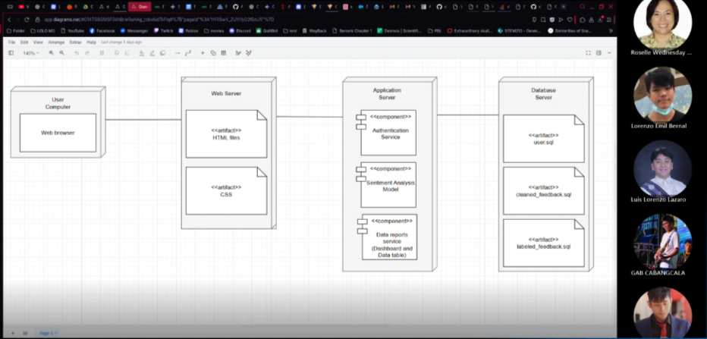
Sprint Review with Ms. Roselle Gardon – 12/11/25

Recording with Ms. Wednesday: QUADThink SCSPROJ Adviser Meeting-20251211_042819UTC-Meeting Recording.mp4

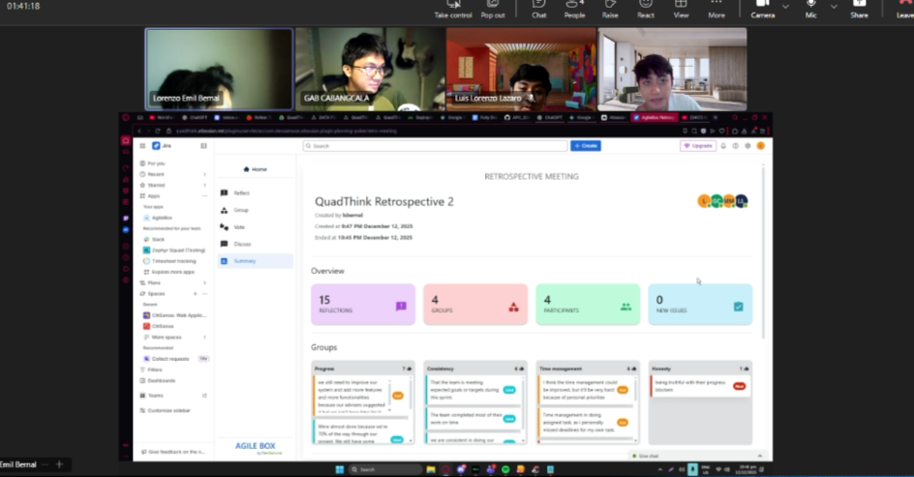
Sprint Retrospective – 12/12/25
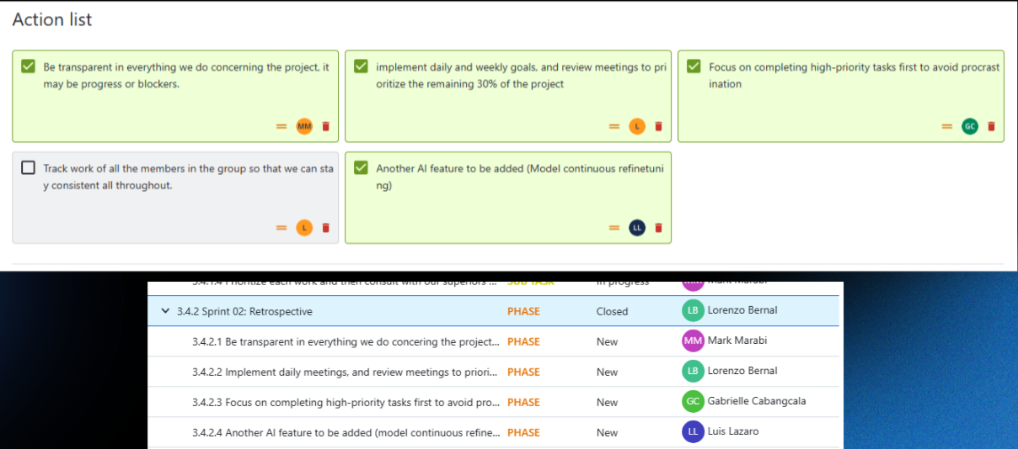

Recording: Meeting in QUADTHINK-20251212_215522-Meeting Recording.mp4

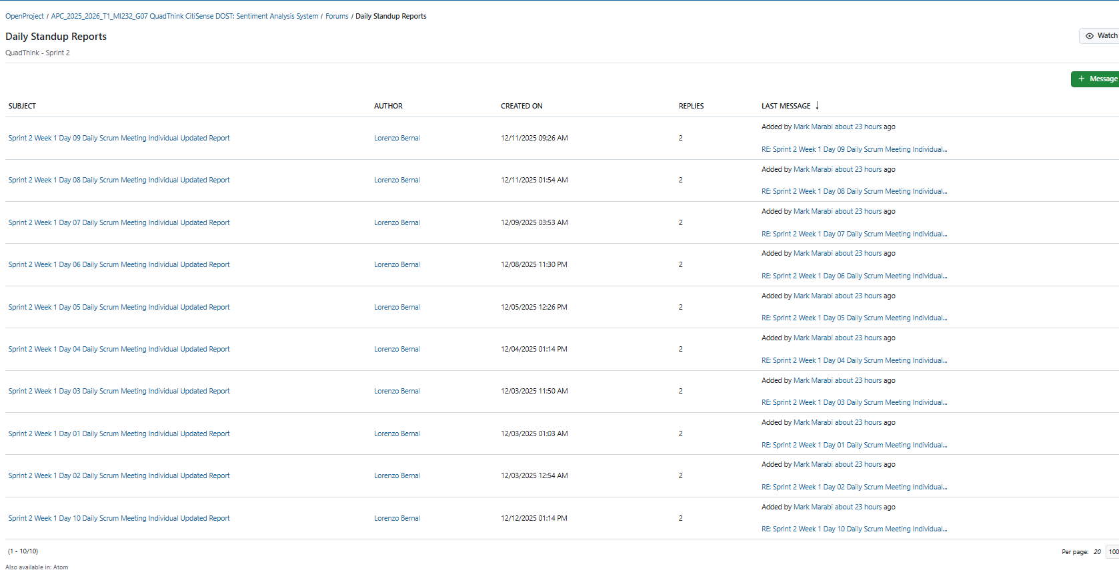
Daily Sprint Reports

Daily Standup Reports | APC_2025_2026_T1_MI232_G07 QuadThink CitiSense

